Franchisee Bill Collection Package

Scope:
- Web based application designed using PHP and Oracle Database.
- Application is available in Madurai application server with url http://10.40.32.100/cdrfranch and for db, Dotsoft database is used.
- Can be accessed via Java Script Enabled Internet Explorer (6.0 or above) connected to CDR –WAN and also from broadband CDR VPN.
- The franchisee shall collect landline, mobile and will payments in this module. Then at the end of the day, he takes printout of the daily list and attest it and give it to concerned SSA Accounts Officer.
- The bill data view (read only) is given by TCS and payments are saved in intermediate Madurai DS Server and then uploaded by concerned AO into PMS.

Scope of Accounts Officer:

- The Accounts Officer can login in this application from the URL : http://10.40.32.100/cdrfranch/aologin.php and can view the reports for each franchisee and for the selected date.
- The concerned Accounts Officer can control the franchisee from collecting payments with respect to date and time by Terminal mapping similar to Dotsoft terminal mapping.
- The concerned SSA AO should enter the payments as offline in the PMS module as being done for Post Office payments.

The various screen shots of this package with working are explained as follows.

Shot 1: Franchisee Login Screen. Username and password can be had from SSA’s.
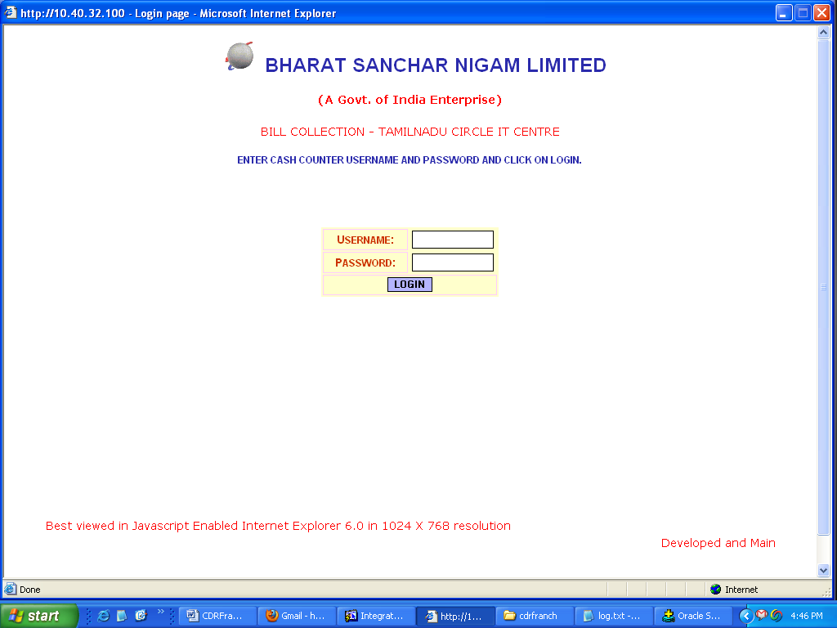

Shot 2: After login, here is Landline bill collection screen. In this, after entering phone number and selecting STD code, click on Get Details button. If bill is pending, the net amount will come to display. And depending upon the mode of payment, select Cash/DD/Cheque and enter the relevant details and finally click on Save.
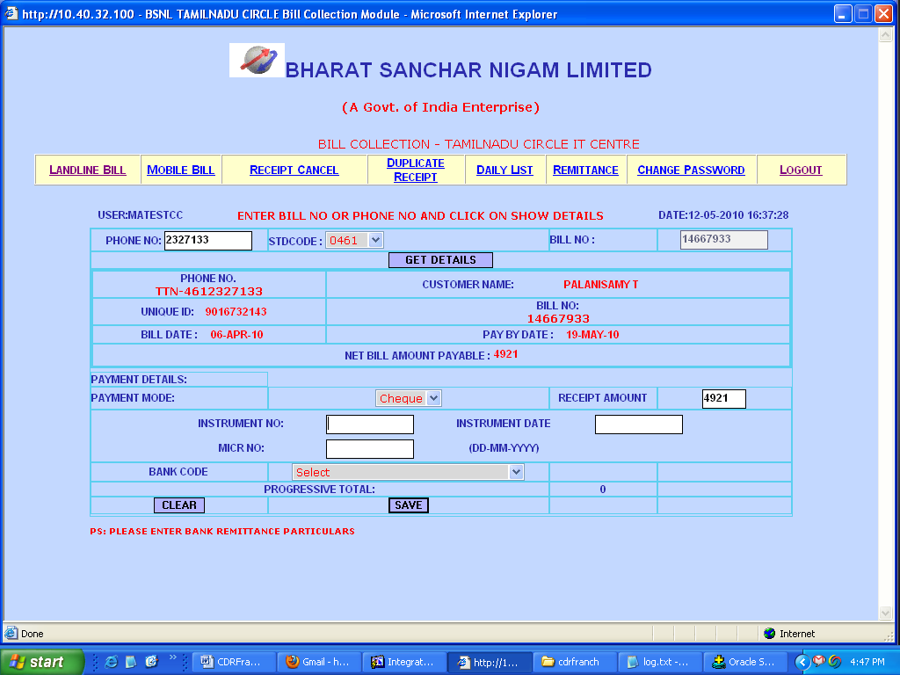

Shot 3: Receipt Display. After saving the collection the receipt comes in display as following screen. The printout of the receipt can be had by clicking Print Receipt button.
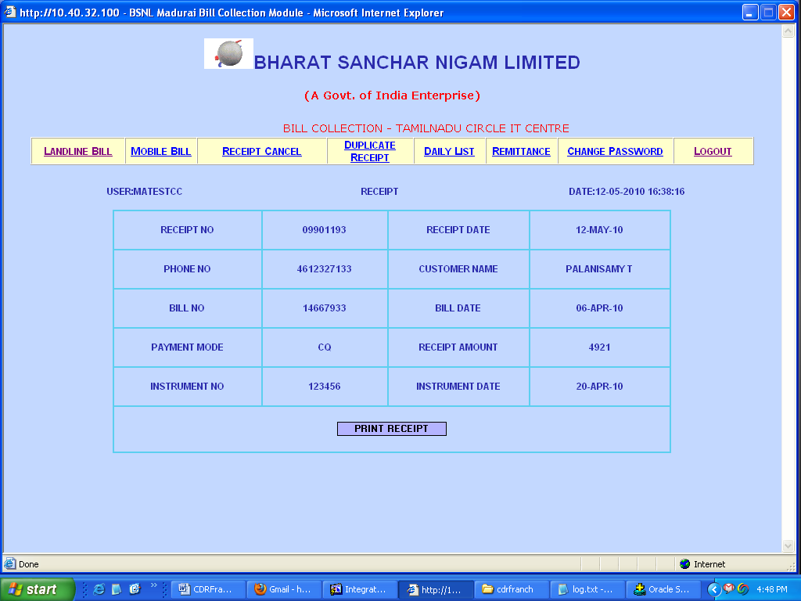
Shot 4: Duplicate Receipt Printout.
In case the receipt has failed to print, duplicate receipt can be had in this page by giving the receipt number. The receipt number can be had from Daily list page.
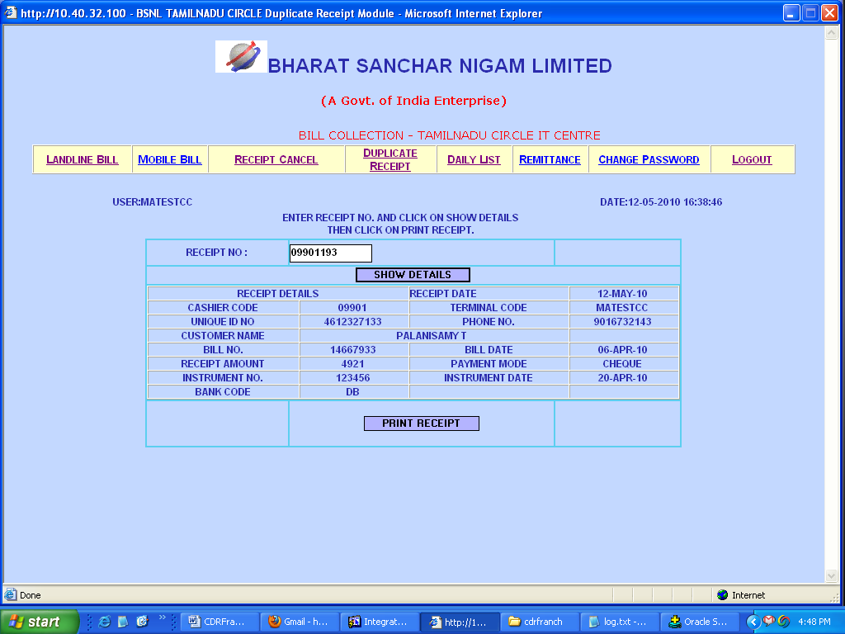
Shot 5: Daily list page:
The Daily list link shows the collections and cancellations made during the day. This can be had printout by clicking on Print button. This printout is to be given to concerned Accounts Officer after verification by the franchisee user. This is to be final and cannot be revert back. So significant care must be taken.
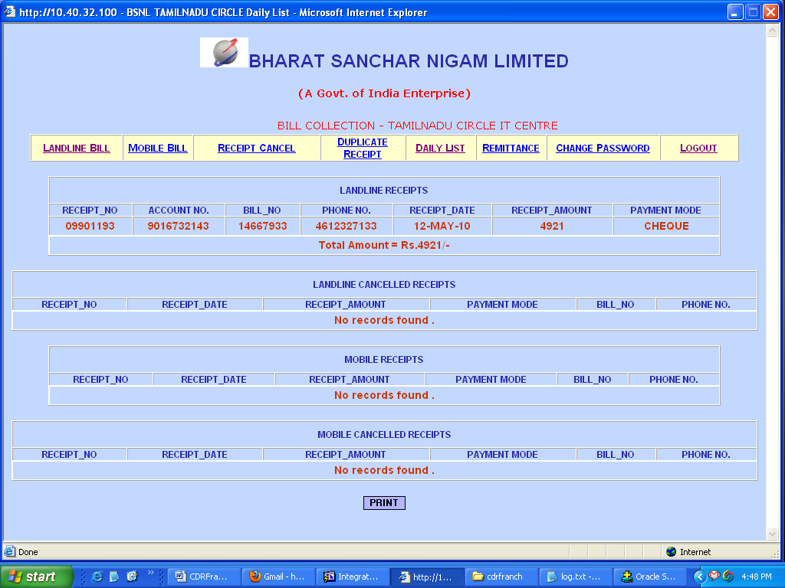
Shot 6: Receipt Cancellation:
In case of wrong entries, the receipt can be cancelled in this page by giving receipt number. Cancellation should be avoided by taking more care.
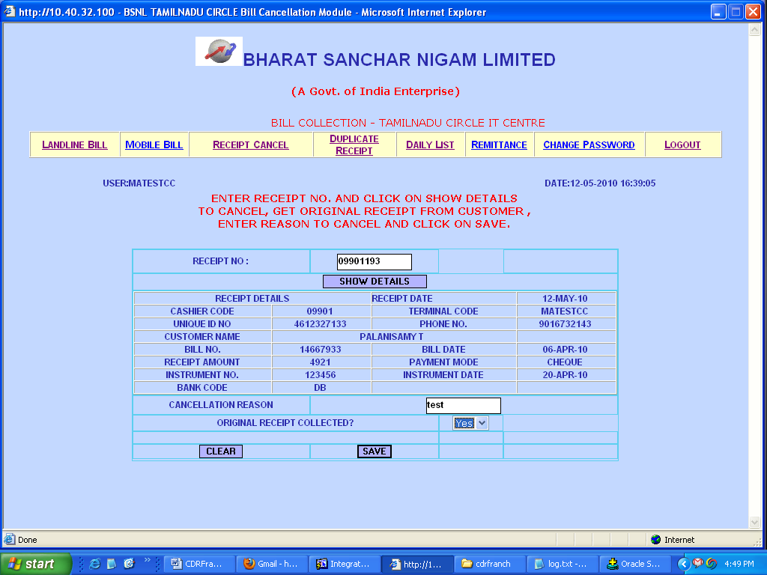

Shot 7: Mobile Bill collection.
Mobile bill can be collected in this page. WLL bill collection also to be included in this module. The payments should be verified and entered by CMTS AO as it is being done in Dotsoft flat file payments.
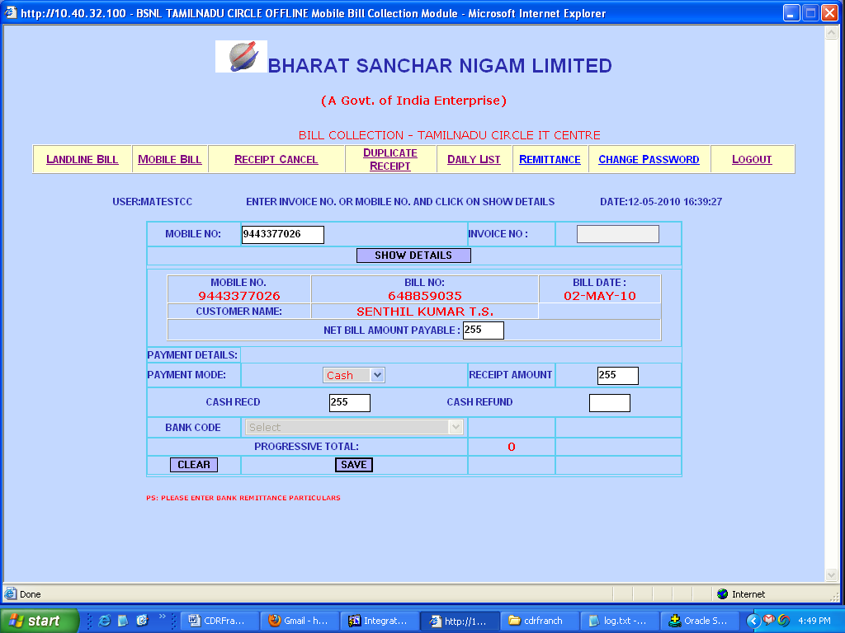
Shot 8: Cash Remittance in Bank.
The franchisee should enter the cash remittance details in this page. The payment made should tally against the receipt number given.
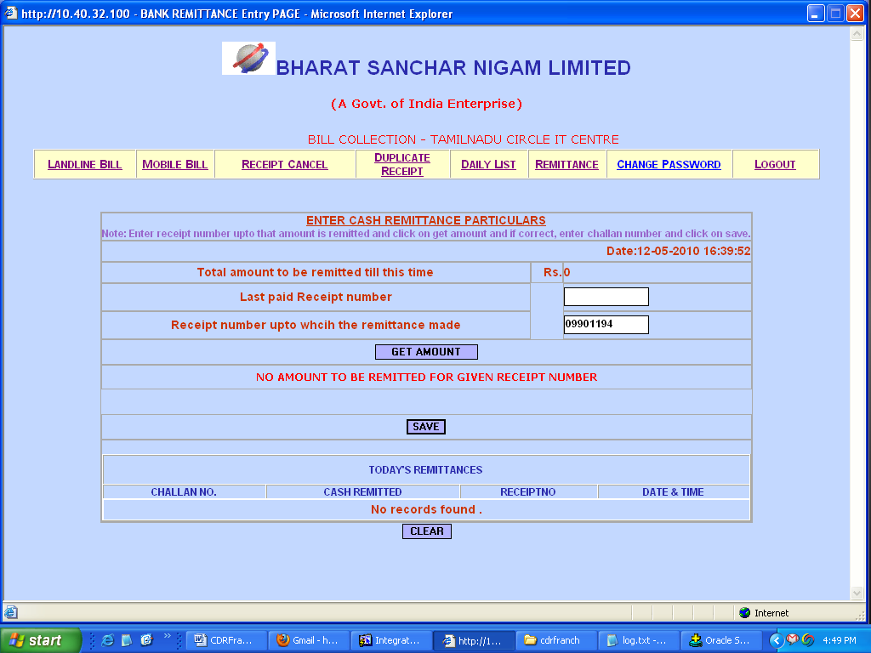
Shot 9: Cheque Remittance in Bank.
The challan number and date of remittance should be entered for each Cheque/DD.
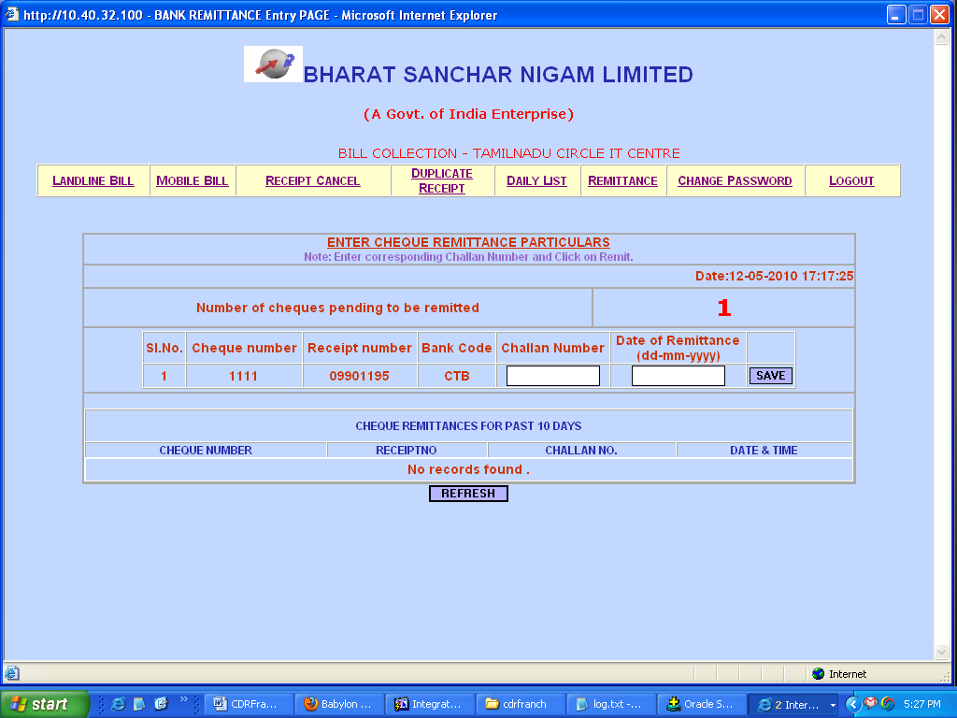
Shot 9: Password Change Page.

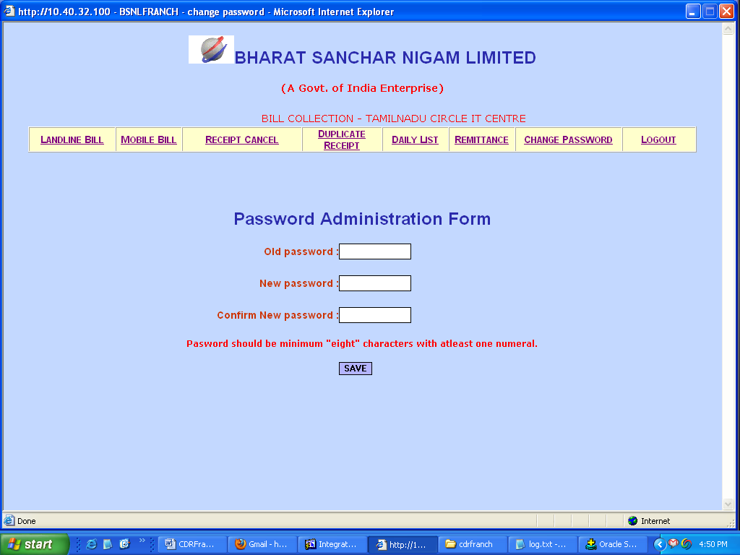
Restrictions implemented:
- User session will be destroyed if no activity is found for last 10 mins.
- User can login only if concerned Accounts Officer has provided Terminal mapping.
- Receipts can be had either in A4 paper or in preformatted Receipt.
4. Accounts Officer can tally the remittance entries with the actual bank statements and can control the franchisee with terminal mapping.

Browser Settings:
In IE, open Page Setup Settings and clear the header and footer settings.
For preformatted receipts, set the margins as 0.25inches in page setup in IE and paper and printer settings are to be done as in dotsoft.

